https://www.scgjsksd.in

Guidelines

Master Sheet Upload Guidelines

Contents

Introduction 2

Target Audience 3

Pre-requisites 4

Application Overview 5

Master Sheet Import 6

Generate Reports 6

Upload Documents 7

SDMS Batch Number 7

Generate Batch Reports 8

Getting Started 9

Generate a new batch 10

Update Batch Information 12

Generate Candidate Sheet 14

Candidate Sheet Structure 15

Filling Candidate Sheet 16

Fields not to be Modified 17

Rules for filling Candidate Sheet 18

Delete Value from Candidate Sheet 19

Candidate Sheet Upload 20

Common Errors – Possible Solutions 21

# Introduction

SCGJ/Safai Karamchari - App is a web application which will be used by Skill Council for Green Jobs and its training partners as an operational and monitoring tool to carry out training of Safai Karamchari pan India.

Due to the increase in the number of candidates being trained all over the country, it becomes difficult to manage all the information manually and maintain records in the excel sheets. This tool will help the training partners to generate different reports and excel sheets through the system and send it to the skill council which was earlier done manually.

This tool will reduce the redundancy that exists in the current system where the training partner used to create different excel sheets for the same candidates where he had to enter the same information several times.

The document will help the training partner to understand how to feed the data into the system and some common mistakes that are committed while uploading the information of candidates/batches on the application.

# Target Audience

This application is primarily for the training partners, who are affiliated by the Skill Council for Green Jobs to conduct training of Safai Karamcharis under RPL Mode.

The training partners who are provided the access to this application will use this application to perform several different tasks that are aligned to the process which is followed for training Safai Karamcharis. This application serves as a platform to store, retrieve and monitor the information for both the stake holders (Training Partners & Skill Council for Green Jobs).

A training partner can perform the following actions on this platform:

1. Feed Data of a batch into the system
2. Update candidate details
3. Generate reports required for different phases of training
4. Upload attested documents/reports

All these actions will be performed by the training partner in the order that is followed on actual basis during the training.

# Pre-requisites

In order to use the application, following are the pre-requisites that are essential to use the application.

1. Internet Access
2. URL of the application – [https://www.scgjsksd.in](https://www.scgjsksd.in/)
3. Affiliated by SCGJ to conduct training of Safai Karamcharis under RPL
4. Credentials to access the application

# Application Overview

The application has two stakeholders i.e. Training Partner and Skill Council for Green Jobs. For the training partner, there are 5 different modules which will have all the actions/information that are to be performed/required by the training partner during the entire training process.

The different modules available to the training partner are:

1. Master Sheet Import
2. Generate Reports
3. Upload Documents
4. SDMS Batch Number
5. Generate Batch Report

Each of these modules will be used by the training partner to perform actions that were earlier done manually.

## Master Sheet Import

This module will be used as a source of information for the application, where the training partner will enter the information of the candidates and batches through an excel sheet and the fields provided respectively. This module also shows some statistics for the current financial year which are now readily available under the overall information tab.

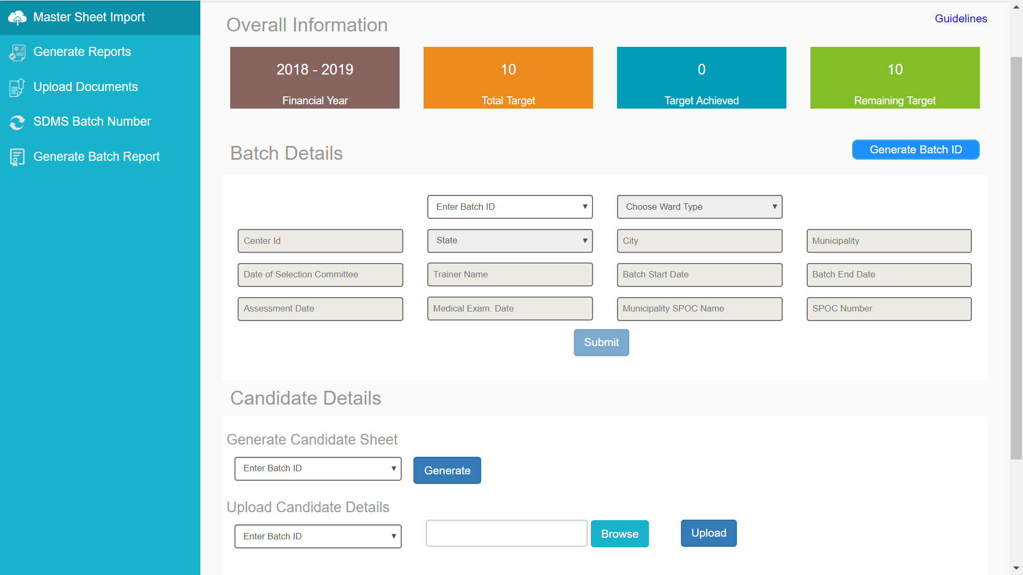

## Generate Reports

This module will help the training partner to generate reports/excel sheets, which are created by the training partner during the training process. The system will generate reports only when the information corresponding to the report is present in the system. Otherwise, the system will raise an error indicating “*Data not found”.*

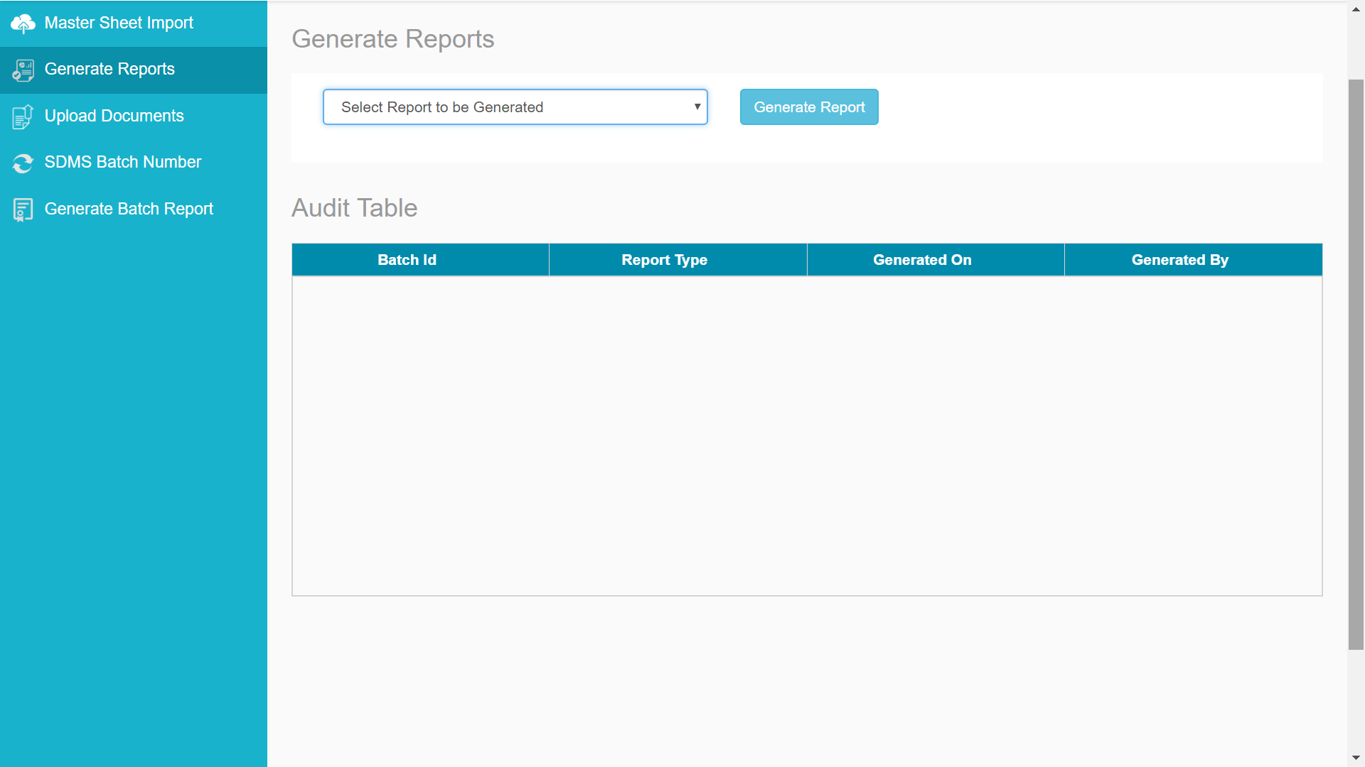

## Upload Documents

This module will be used by the training partner to upload all the documents that needs to be sent to the Skill Council by selecting the document type and selecting the batch id for which the document has to be uploaded.

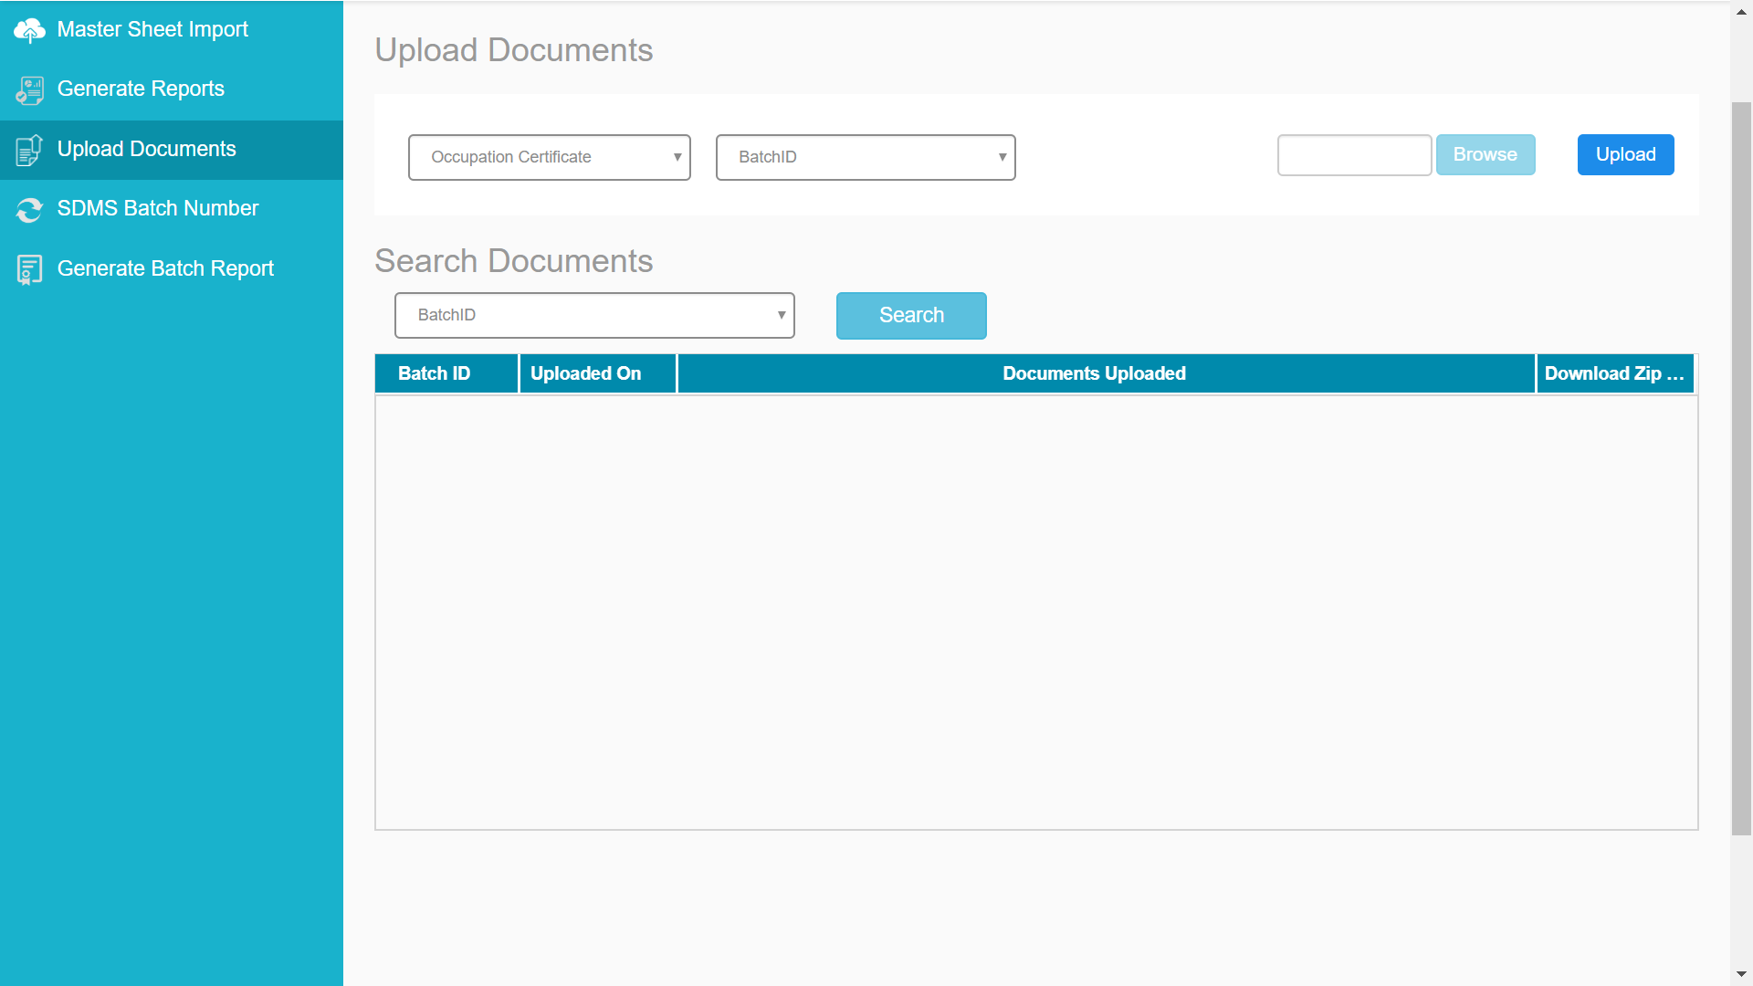

## SDMS Batch Number

This module will be used by the training partner to assign the SDMS Batch Number to a particular batch. The training partner can also update the SDMS Batch Number that is allotted to a batch id using the update batch number functionality. If the user wants to search the batch number that has been assigned to a batch id, he/she can do that using the search updated batch number functionality.

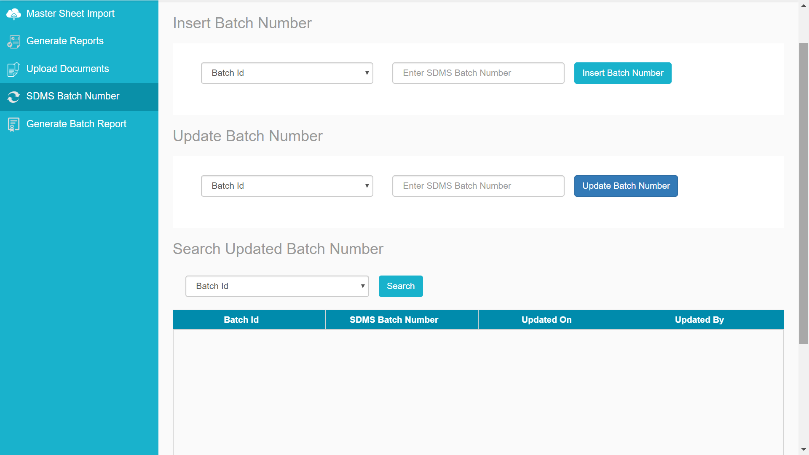

## Generate Batch Reports

The generate batch reports module will allow training partner to generate the final batch report for a batch by selecting the batch id from the dropdown and adding the images for each day.

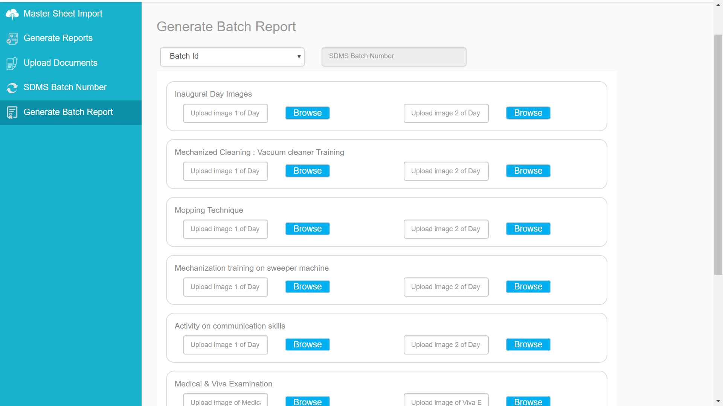

# Getting Started

In order to start using the different functionalities of this application, the first step is to insert information into the system. These are the following steps that needs to be followed to insert information in the system.

**Steps:**

1. Generate a batch Id
2. Add information of the batch under batch details section
3. Generate Candidate Master Sheet for a batch Id
4. Enter the details of the candidates in the master sheet
5. Upload the candidate details in the system.

In order to enter the information in the system, please follow the steps given on the next page in the same order as described.

# Generate a new batch

To generate a new batch, please follow the given steps:

**Steps:**

1. Click on the Generate Batch Id Button
2. A pop-up box asking for municipality will appear, Add the name of the municipality
3. Once you have added the municipality name, click on the Generate button
4. Once you click on the Generate Button, Batch Id will be generated

Please refer to the snapshots below:

Step – 1:

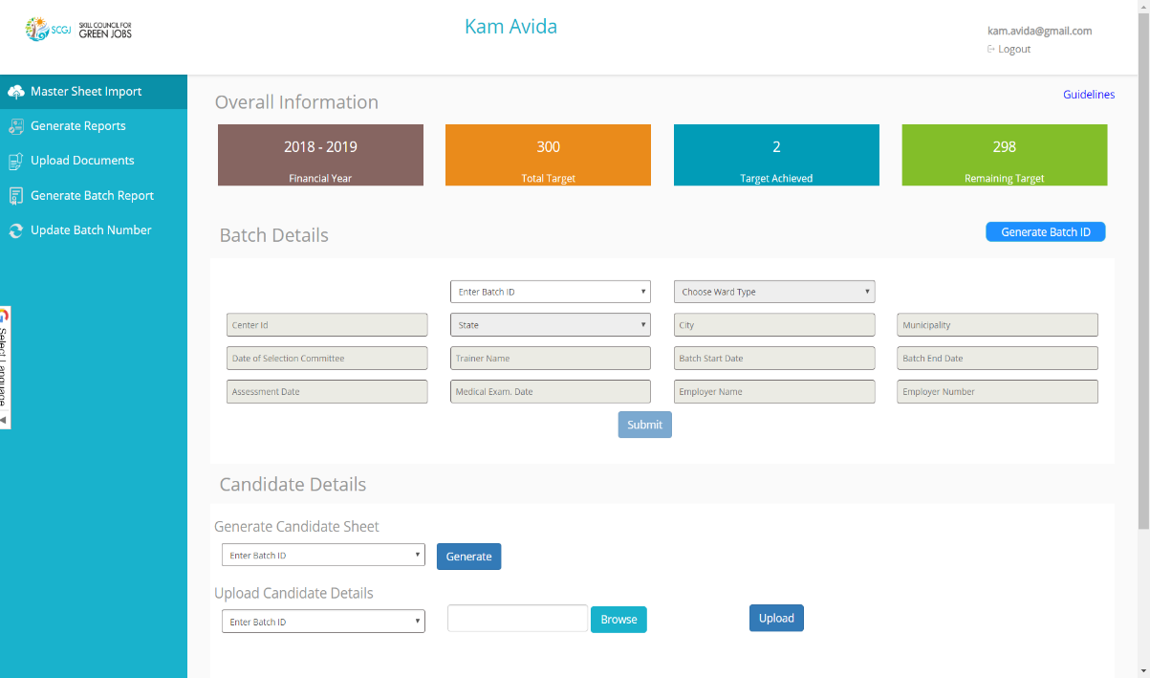

Step – 2:

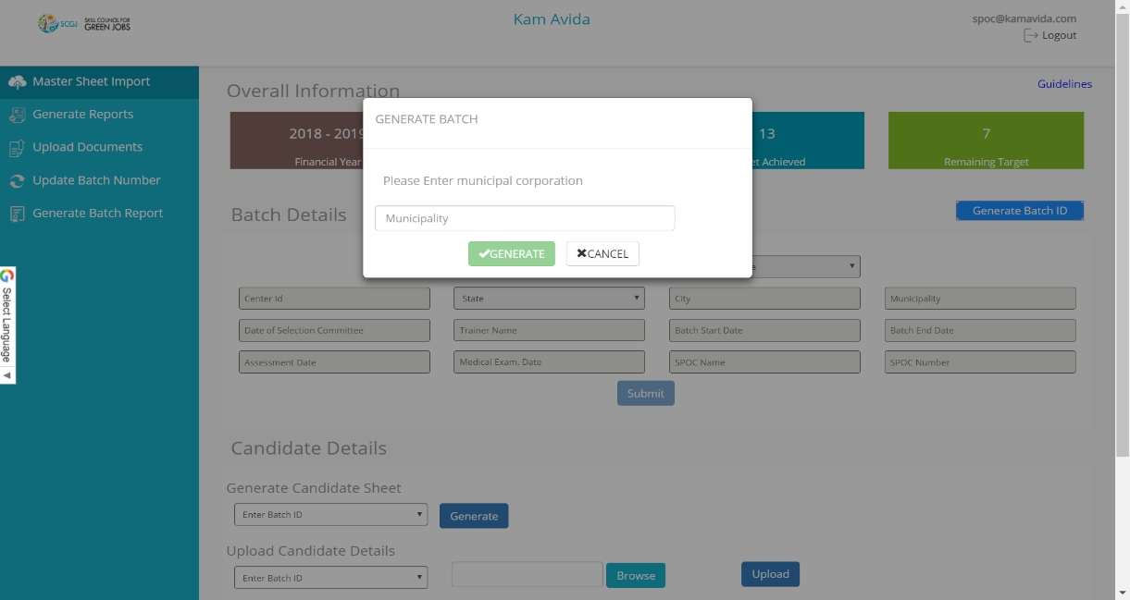

Step – 3:

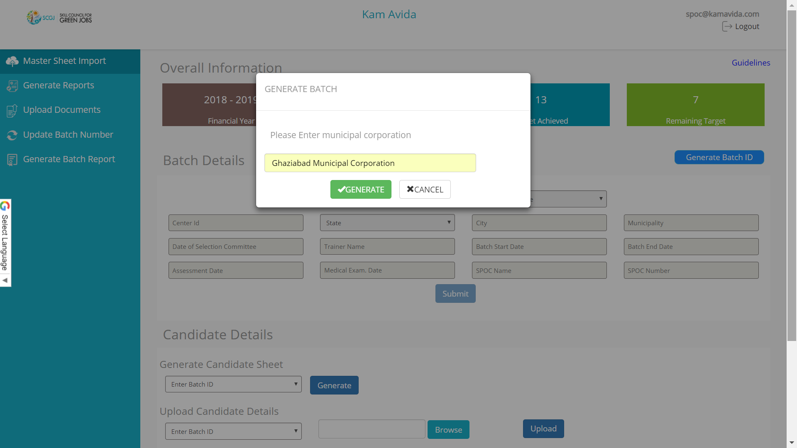

Step – 4:

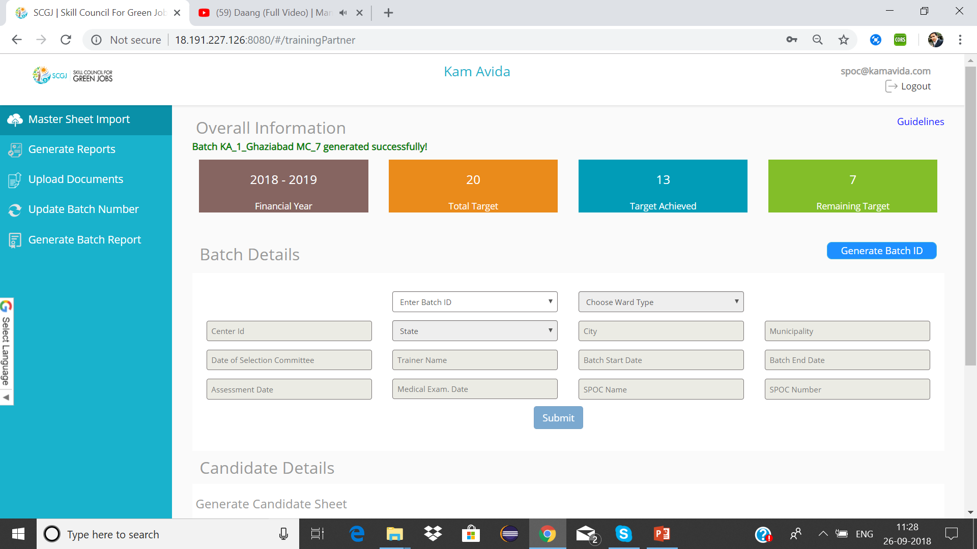

**Format of batch Id** –

*Initials of TP_NSDC Reg. Number _ Name of municipal corporation_Batch Number*

***NOTE: While generating a batch, the user should enter the full name of the municipality.***

# Update Batch Information

To update the batch information, please follow the given steps:

**Steps:**

1. Navigate to batch details section and click on the **Enter Batch ID** drop down
2. This will show a list of batch id that have been created by the training partner
3. Choose the batch for which information has to be updated
4. Once the Batch ID has been selected, all the fields will be enabled
5. Enter the mandatory fields (Centre ID, State, City, Municipality)
6. Click on Submit button, you will see a success message “Batch Details inserted successfully”

Please refer to the snapshots below:

Step – 1:

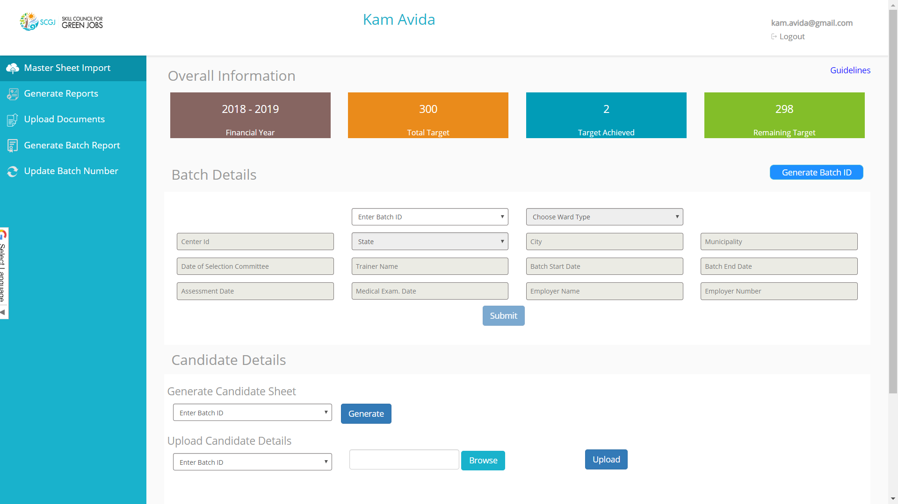

Step – 2:

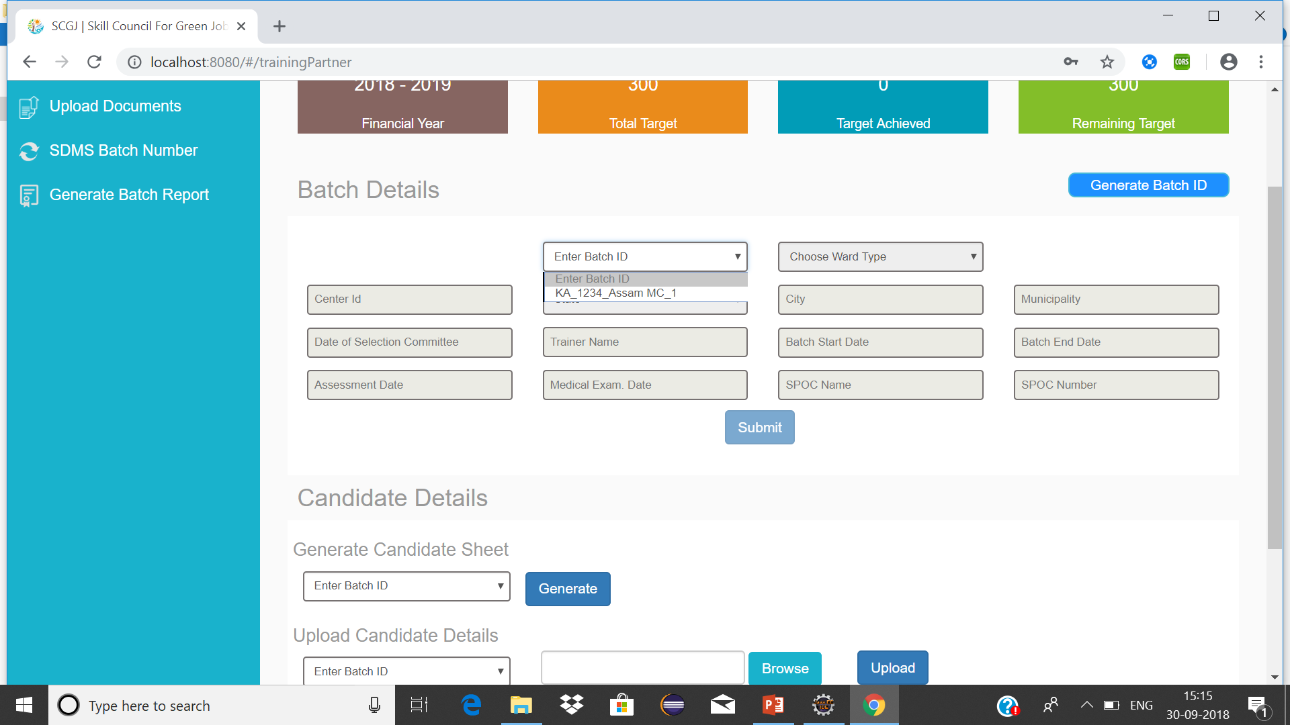

Step – 3:

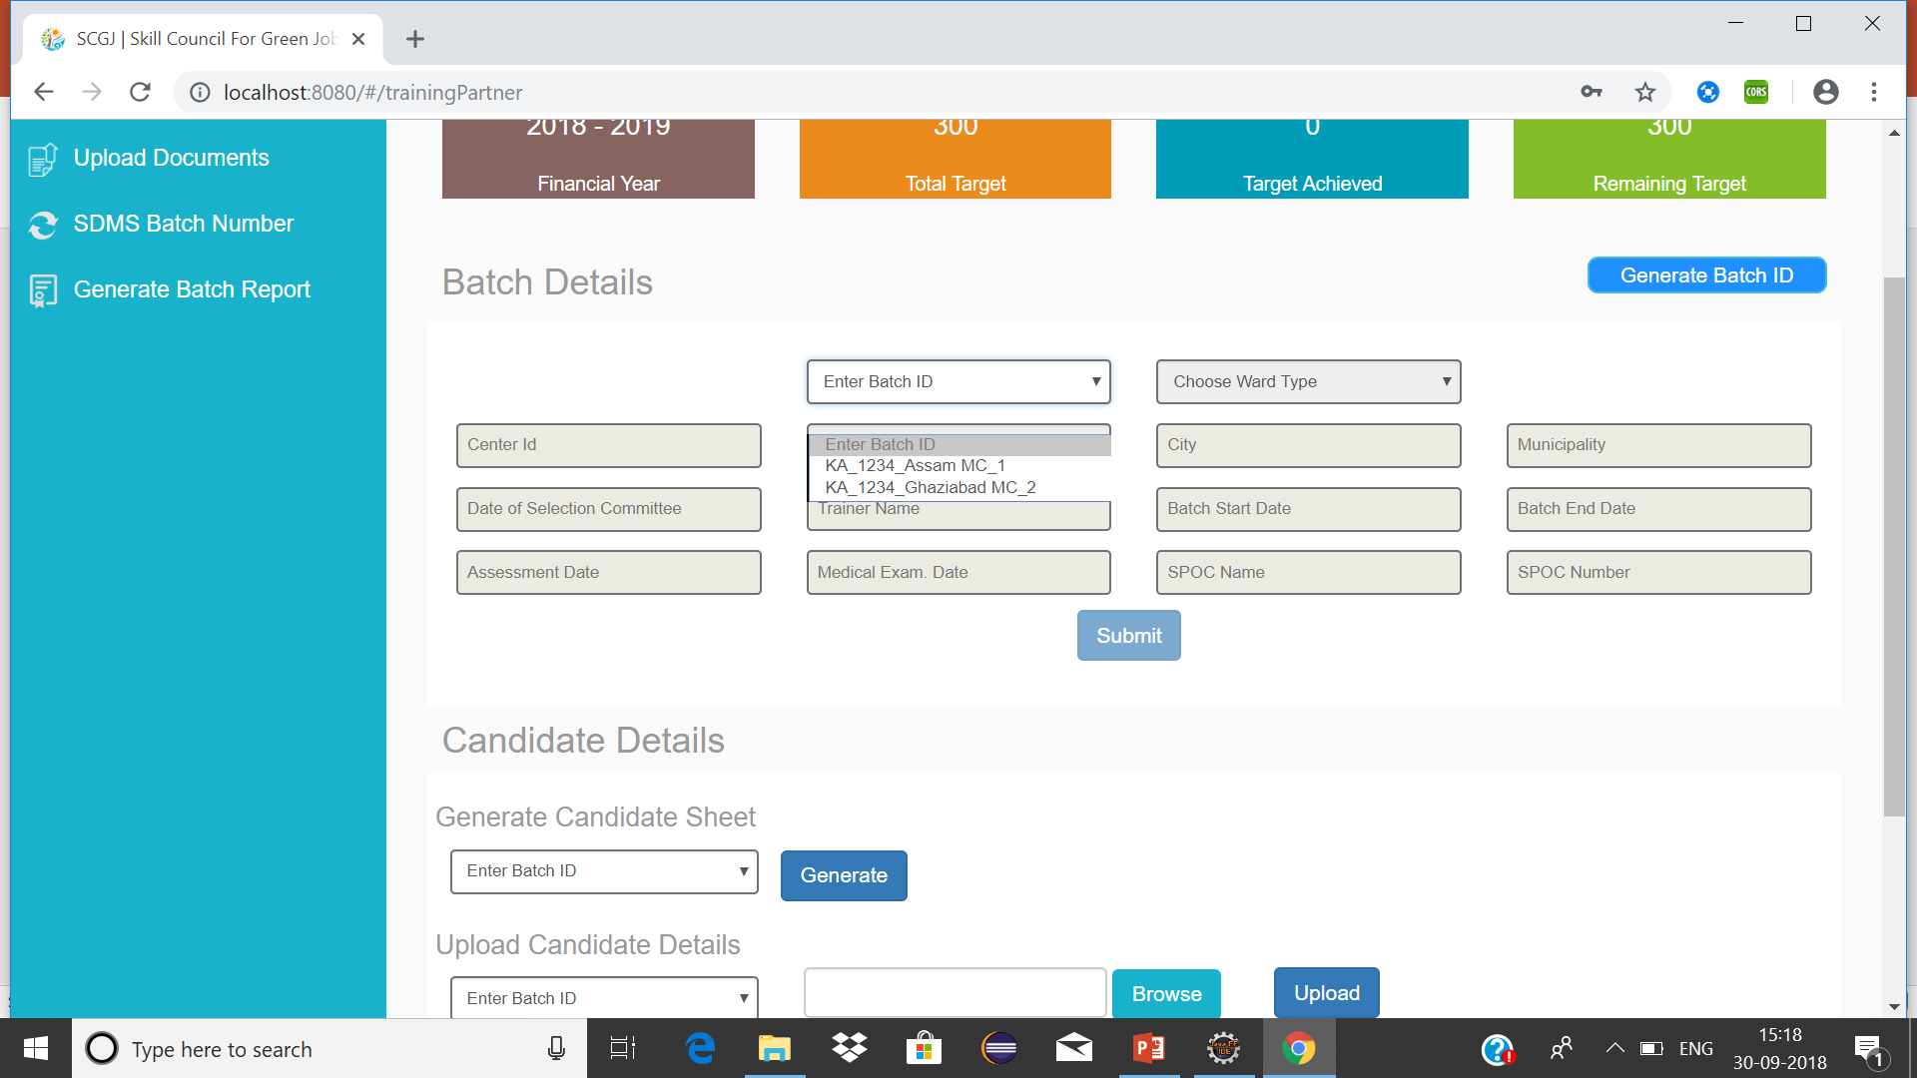 s

Step – 4:

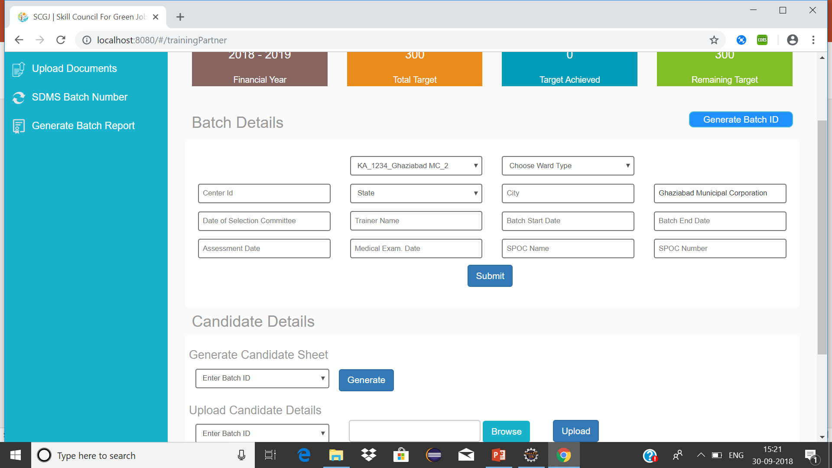

Step – 5:

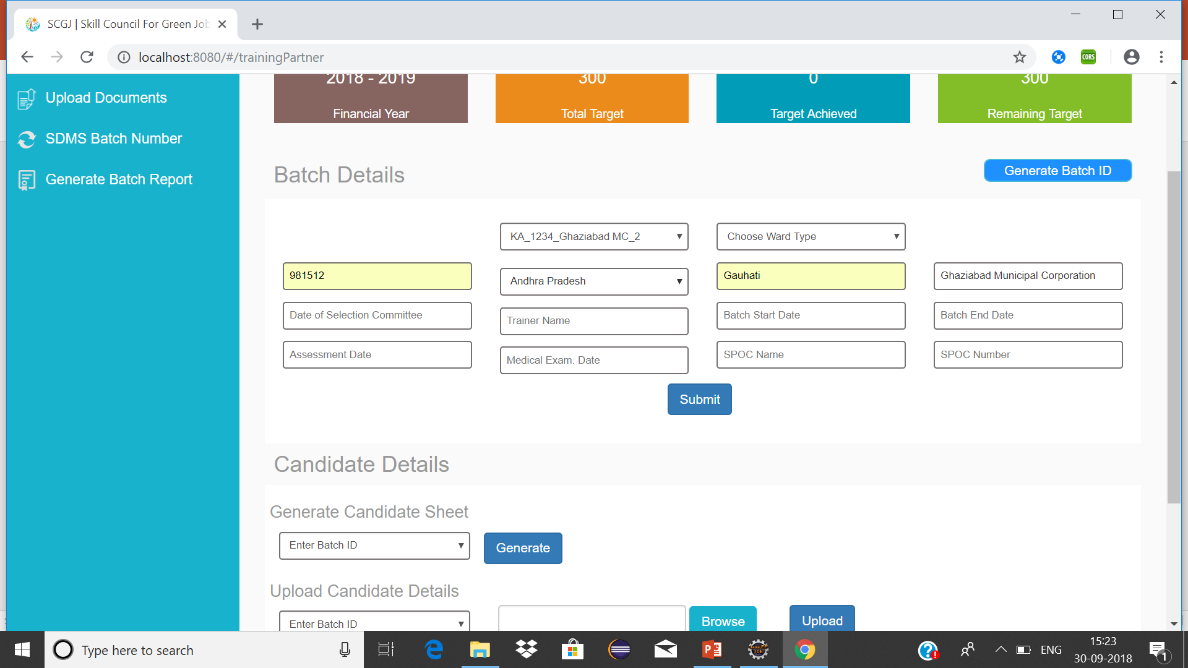

*Note*: *The* (Center Id, State, District, Municipality) are mandatory *to fill before any information is inserted in the system. Municipality will contain the name of the municipal corporation which was filled while generating a batch (User can also update the municipality)*

Step – 6:

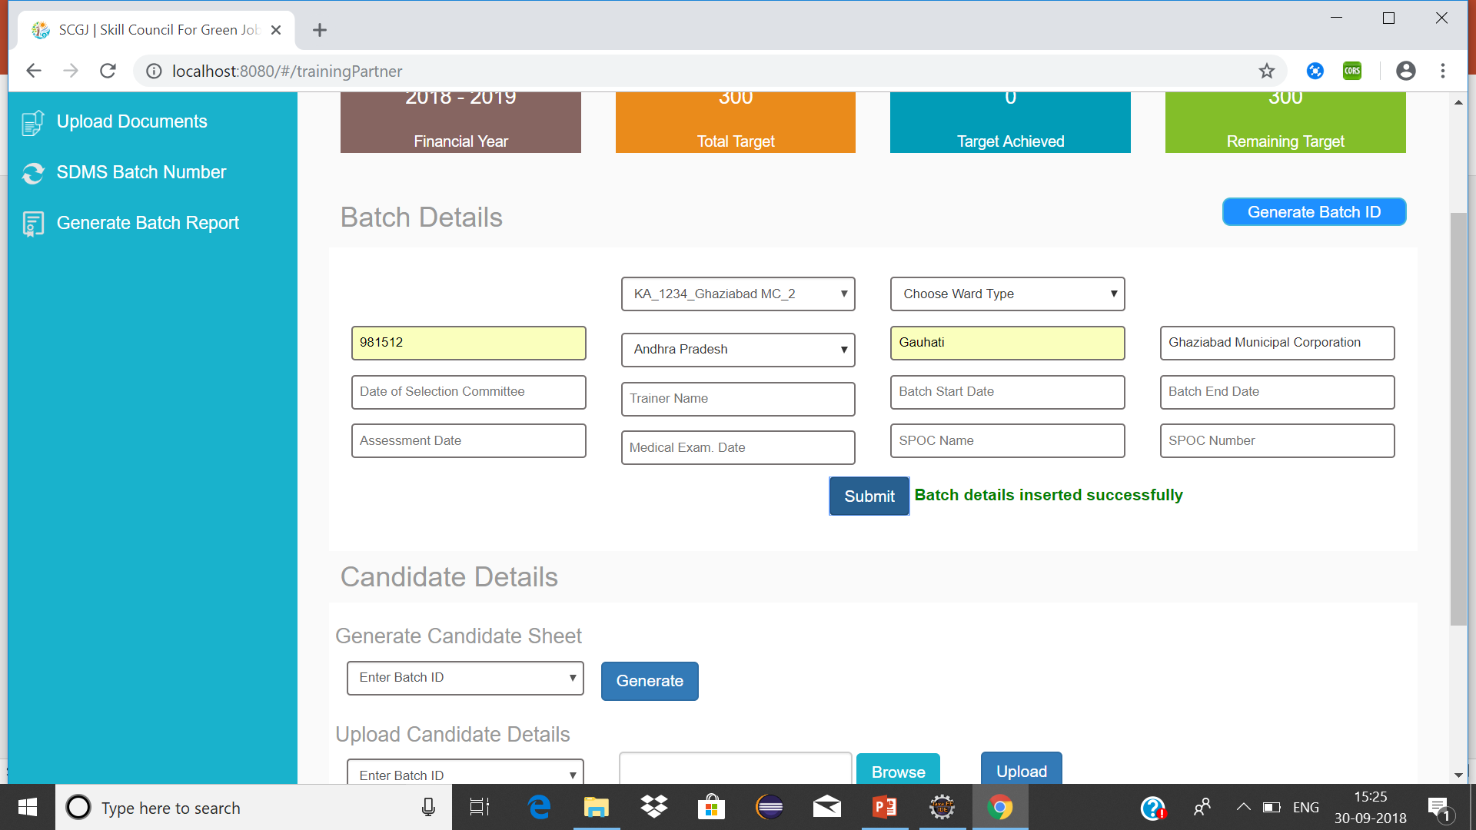

*Note: Once these details are inserted, the user can update the other fields as and when the information is available by selecting the batch id for which the information has to be updated.*

# Generate Candidate Sheet

To generate the candidate sheet (Master Sheet), please follow the given steps:

**Steps:**

1. Navigate to the Candidate Details Section
2. Navigate to Generate Credential Sheet to generate the master sheet and select the Batch – Id for which the sheet has to be generated
3. After selecting the batch Id click on **Generate** button, the file will get downloaded

Please refer to the screen shots below:

Step – 1:

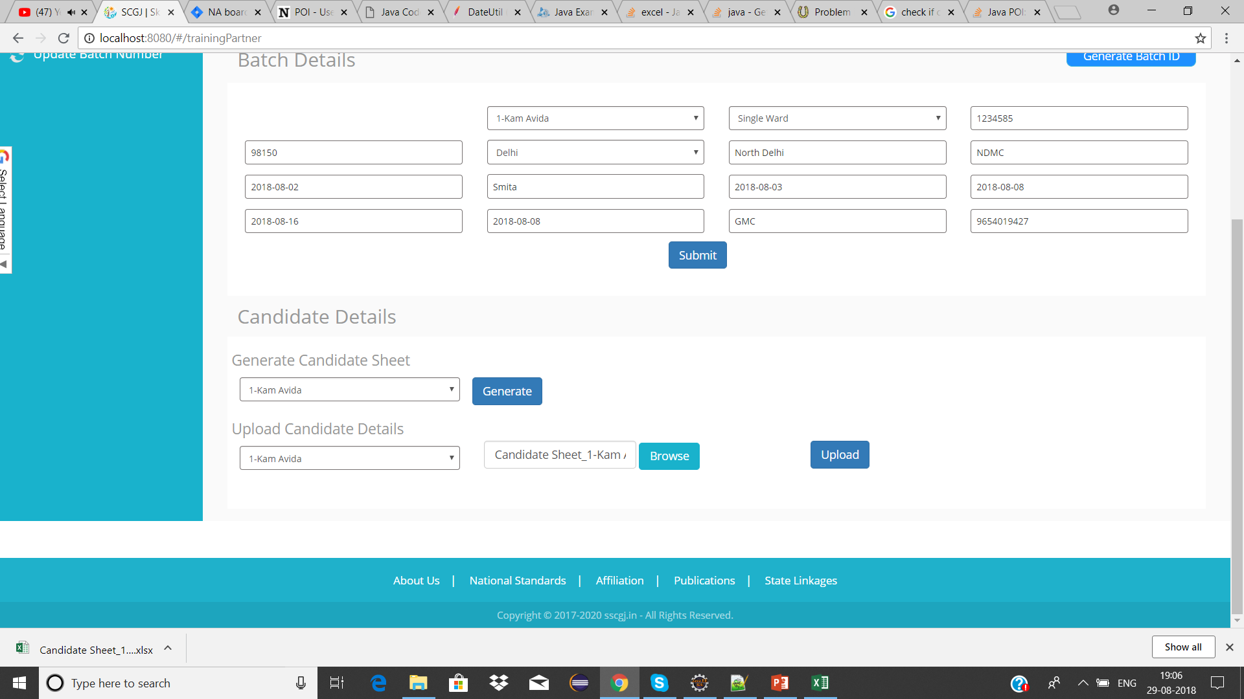

Step – 2:

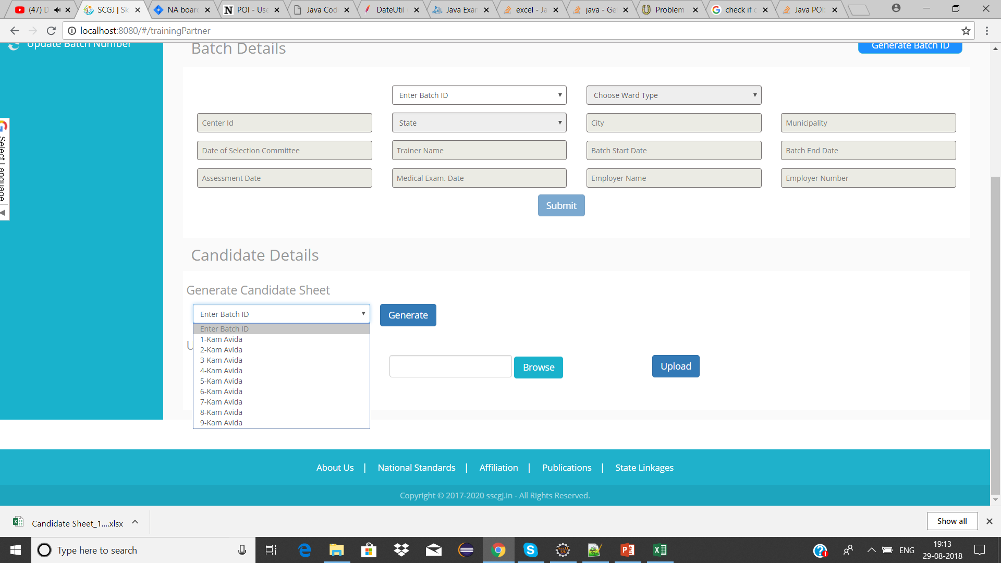

Step – 3:

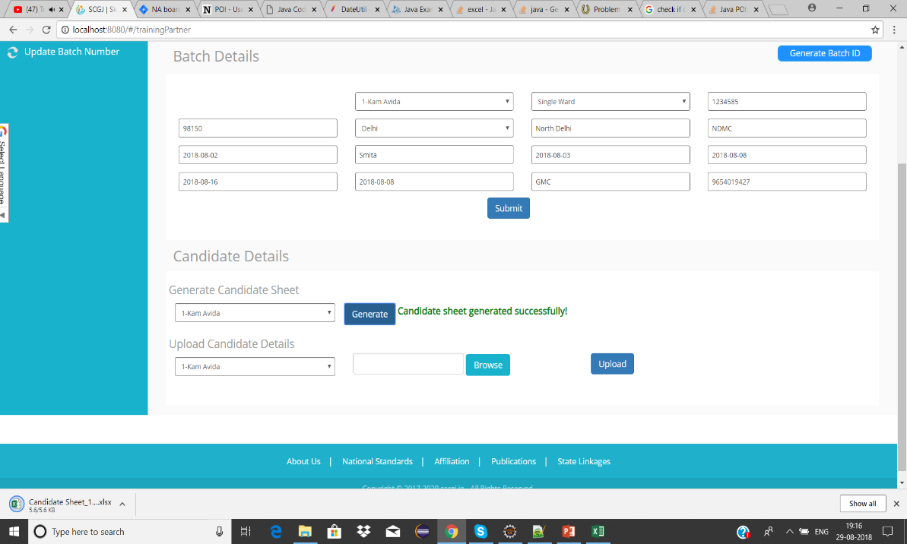

## Candidate Sheet Structure

The candidate sheet comes with some pre-filled columns, the user has to fill the excel sheet from row number 7 without disturbing the structure of the excel sheet.

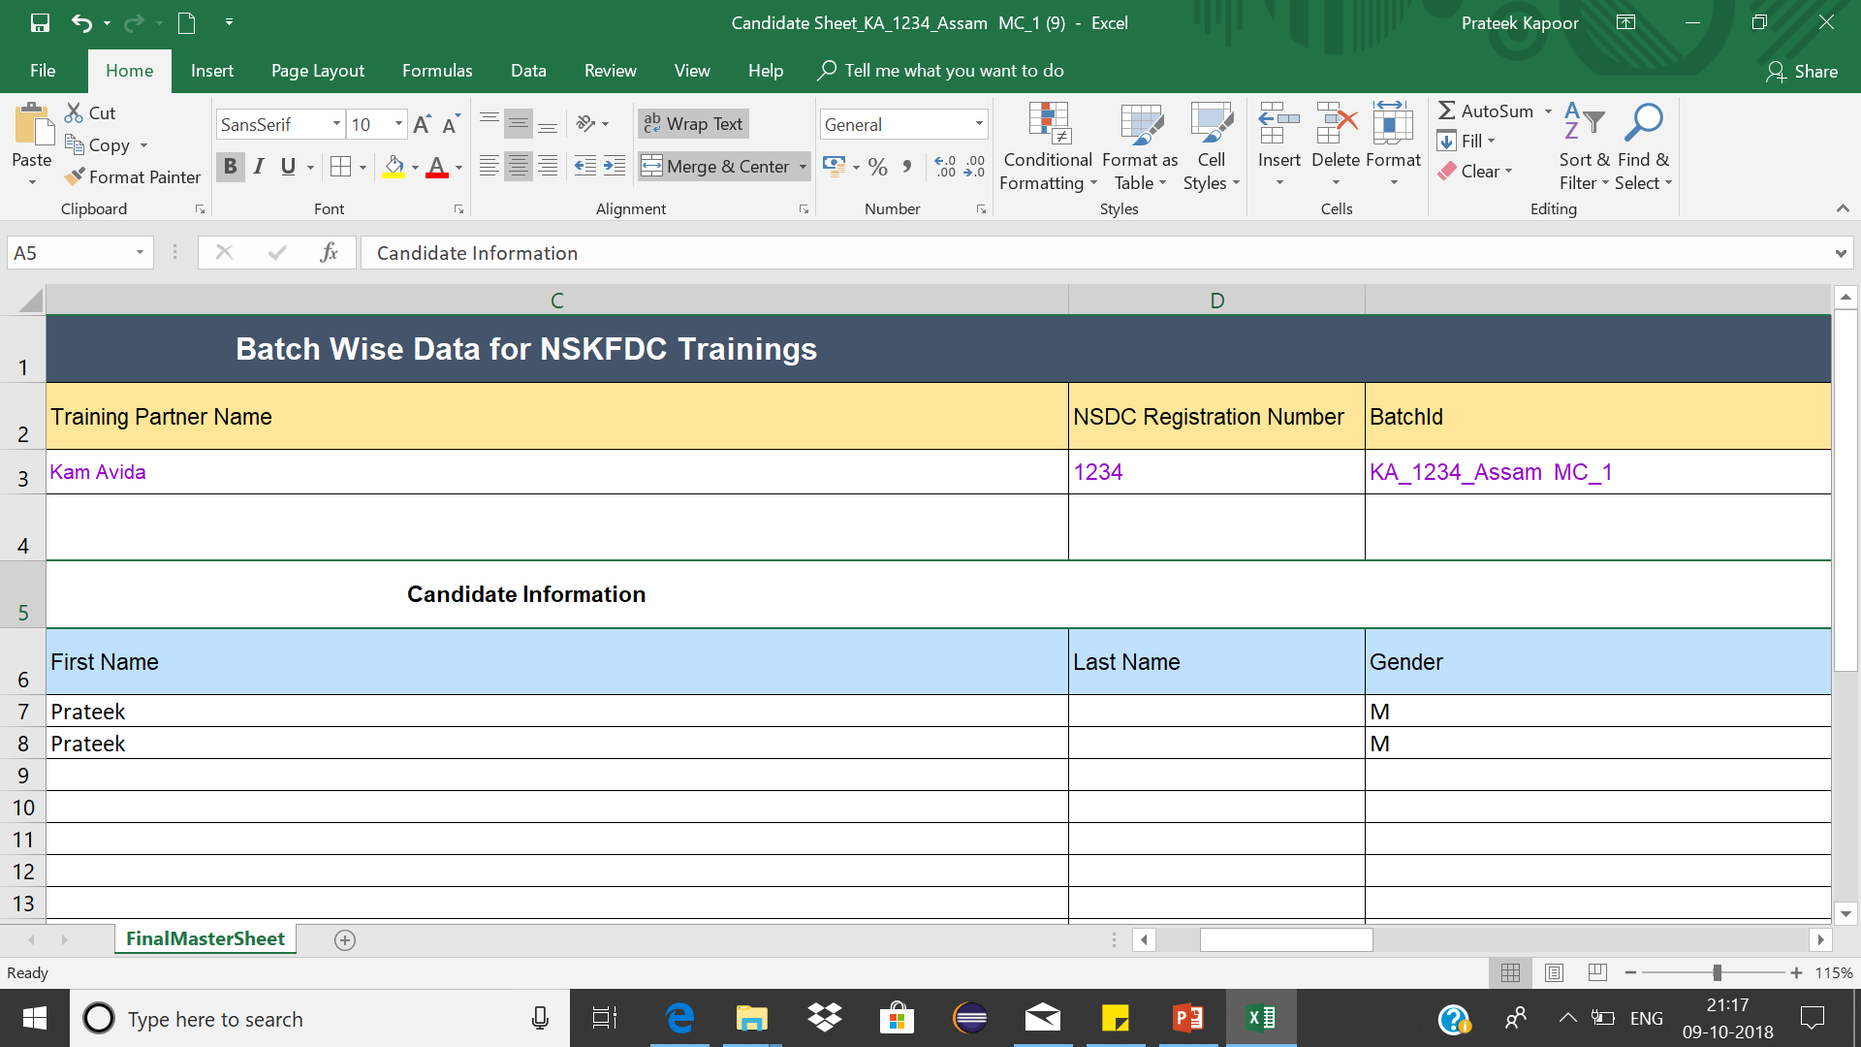

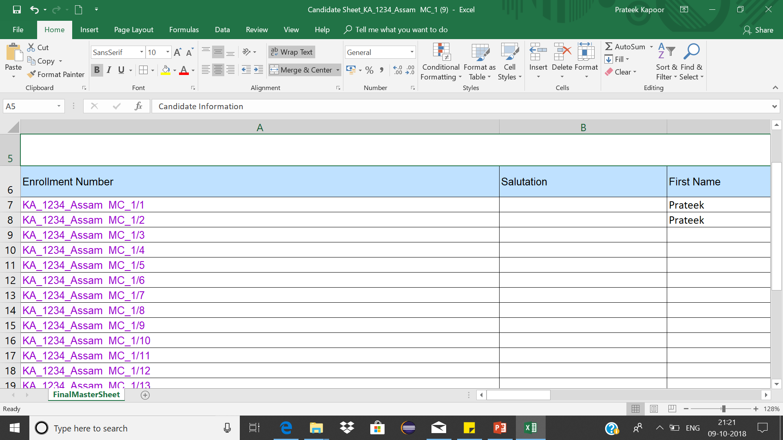

Batch - Id

Auto generated enrolment numbers till 50

Note: *The candidate sheet comes with pre-filled enrolment numbers till 50, if the training partner has less than 50 candidates in the batch then he/she should delete the entire rows from below before uploading the sheet*.

## Filling Candidate Sheet

The Candidate Sheet generated by the system has the following columns which the user will edit/update. There are some columns that are mandatory (marked in red) to be filled before uploading the candidate sheet.

|  |
| --- |
| Candidate Information |
| Enrolment Number |
| Salutation |
| First Name |
| Last Name |
| Gender |
| DOB |
| Age |
| Mobile Number |
| Education Level |
| State |
| District |
| Aadhaar Card Number |
| Id Proof Type (Other than Aadhaar) |
| Id Proof Number (Other than Aadhaar Card) |
| Occupation / Category |
| If MS (MS Id) |
| Relation with SK/MS |
| Bank Name |
| IFSC Code |
| Bank A/C Number |
| Residential Address |
| Workplace Address |
| Medical Exam Conducted (Yes/No) |
| Assessment Result |
| Employment Type |
| Whether Hired on adhoc/contractual basis |
| Contact Details of Employer |
| Monthly Salary |
| PF/ESI Provided |

|  |
| --- |
| Guardian Information |
| Guardian Type |
| First Name of Father |
| Last Name of Father |
| Mother Name |

Note: *The fields marked in red are mandatory fields, which have to be filled before uploading the candidate sheet.*

### Fields not to be Modified

This section contains the list of columns/rows that should not be edited/modified as this will bring inconsistency in data and the system will not allow the sheet to be uploaded.

1. Batch Id in the excel sheet

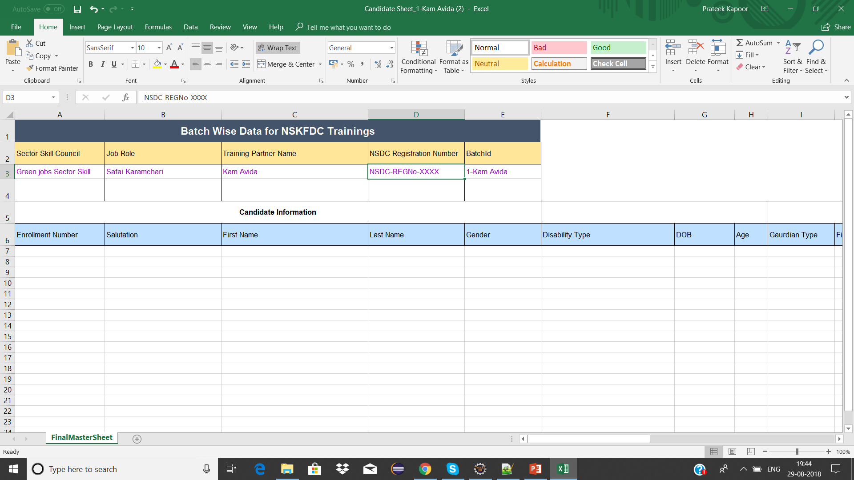

*System will not accept the file if the Batch – ID in the sheet does not match the Batch – ID chosen while uploading the sheet*

1. Filling the details in the excel sheet

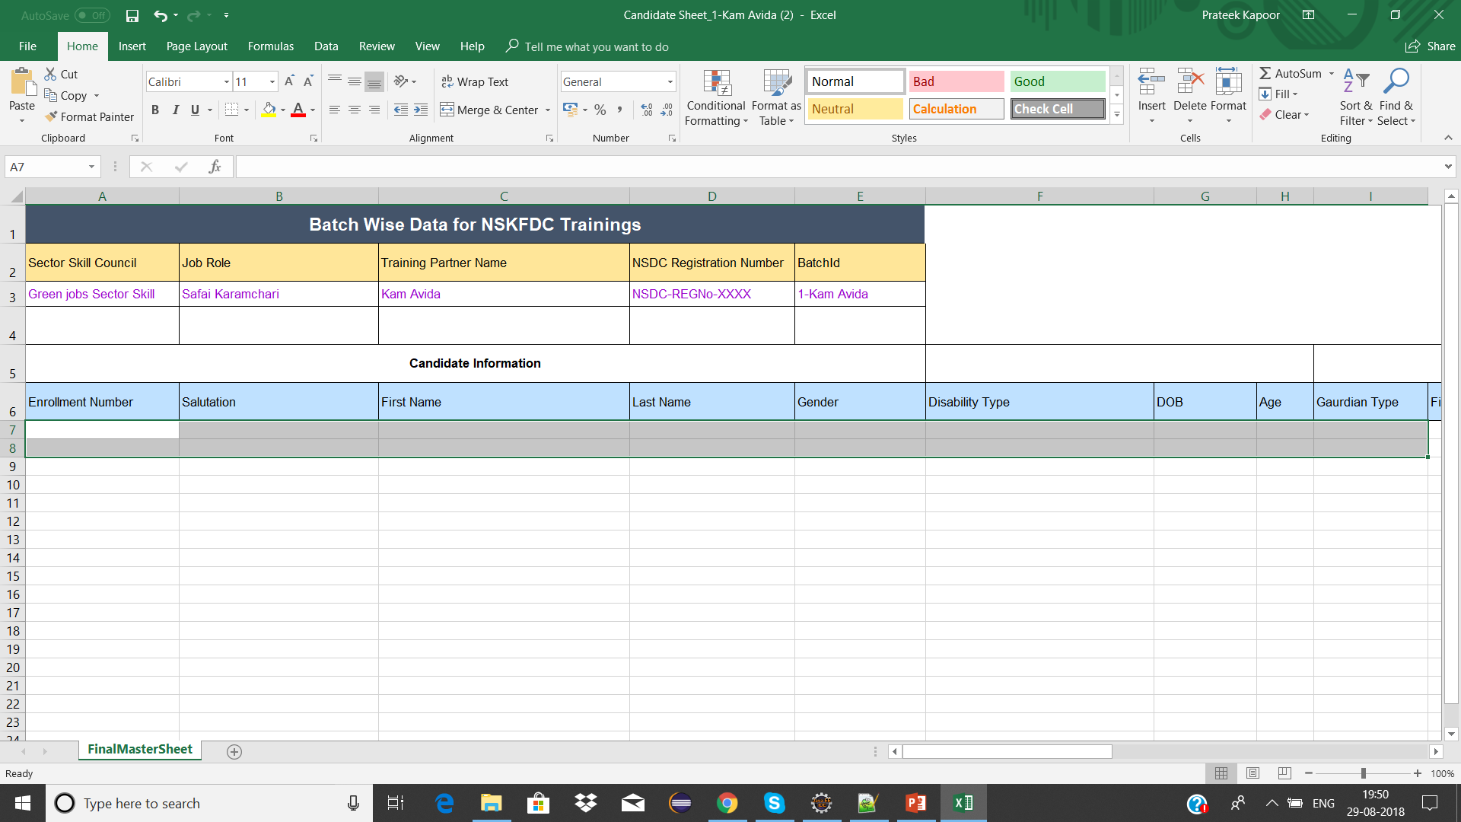

Note: *The candidate/guardian information should be entered by the training partner from row number 7*.

Note: *No row should be deleted/edited before row number 7, not even the name of headers should be changed by the training partner.*

### Rules for filling Candidate Sheet

While filling the details of candidates in the candidate sheet, these are the few rules that the training partner has to follow in order to avoid any inconsistency in the information.

1. The format for enrolment number of the candidate in the excel sheet will have the following format: *Batch – Id / Candidate Number*

Example: KA_1234_Assam MC_1 / 1

1. Once the user has added the data into the sheet, they have to add border to the entire cells and columns in the sheet till where the data is entered in the excel sheet.

Note: *if the sheet does not have border till where the data is entered, then the sheet will not be read by the system. Leading to inconsistency in data.*

1. Set the format of date of birth column to Date (dd-mm-yyyy), if not done then the system will throw an error stating that the column is not set to date format
2. The age of the candidate is calculated by the date of birth. Therefore, if the age is less than 18, the system will not accept that candidate
3. The Aadhaar Number and Mobile Number of all the candidates in the sheet should be unique

### Delete Value from Candidate Sheet

If you wish to delete a value from an excel sheet, follow the given steps:

**Steps:**

Step – 1: Choose the cell whose value has to be deleted and right click on the cell

Step – 2: Once you have right clicked on the cell. Click on clear contents option and your value will be deleted

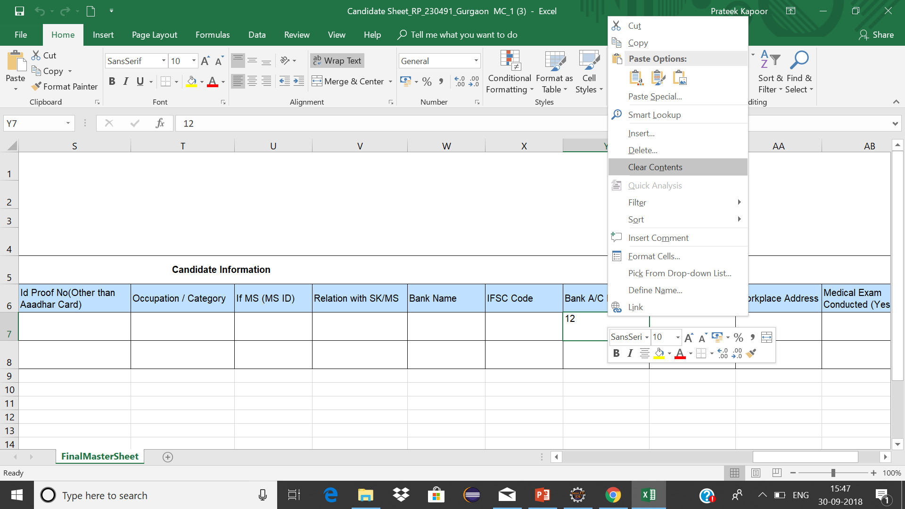

# Candidate Sheet Upload

To upload a candidate sheet, please follow the given steps:

**Steps:**

1. Navigate to Upload Candidate Sheet on the data import page
2. Select the Batch – Id for which the sheet needs to be uploaded & click on browse button
3. Select the sheet by clicking on the browse button & click on the upload button

Please refer to the screen shots attached below:

Step – 1:

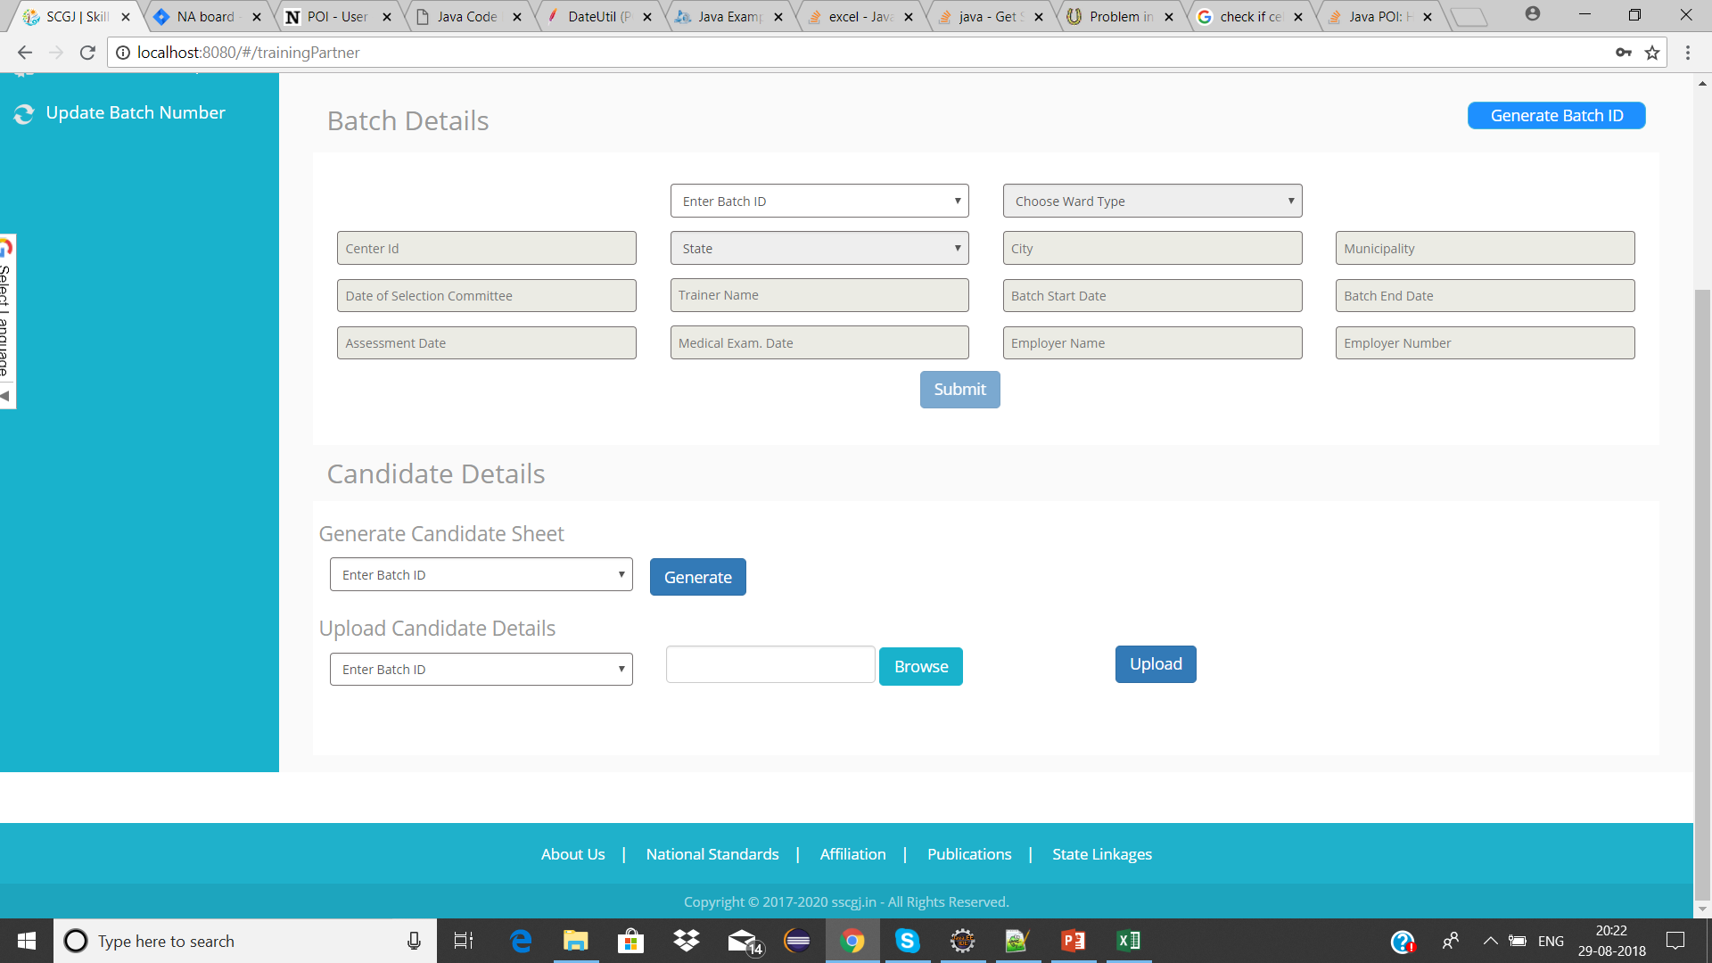

Step – 2:

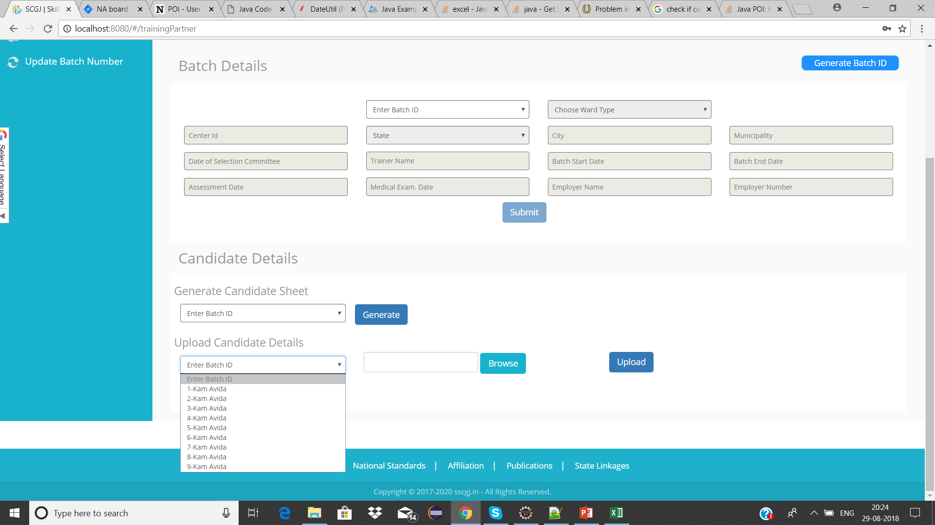

Step – 3:

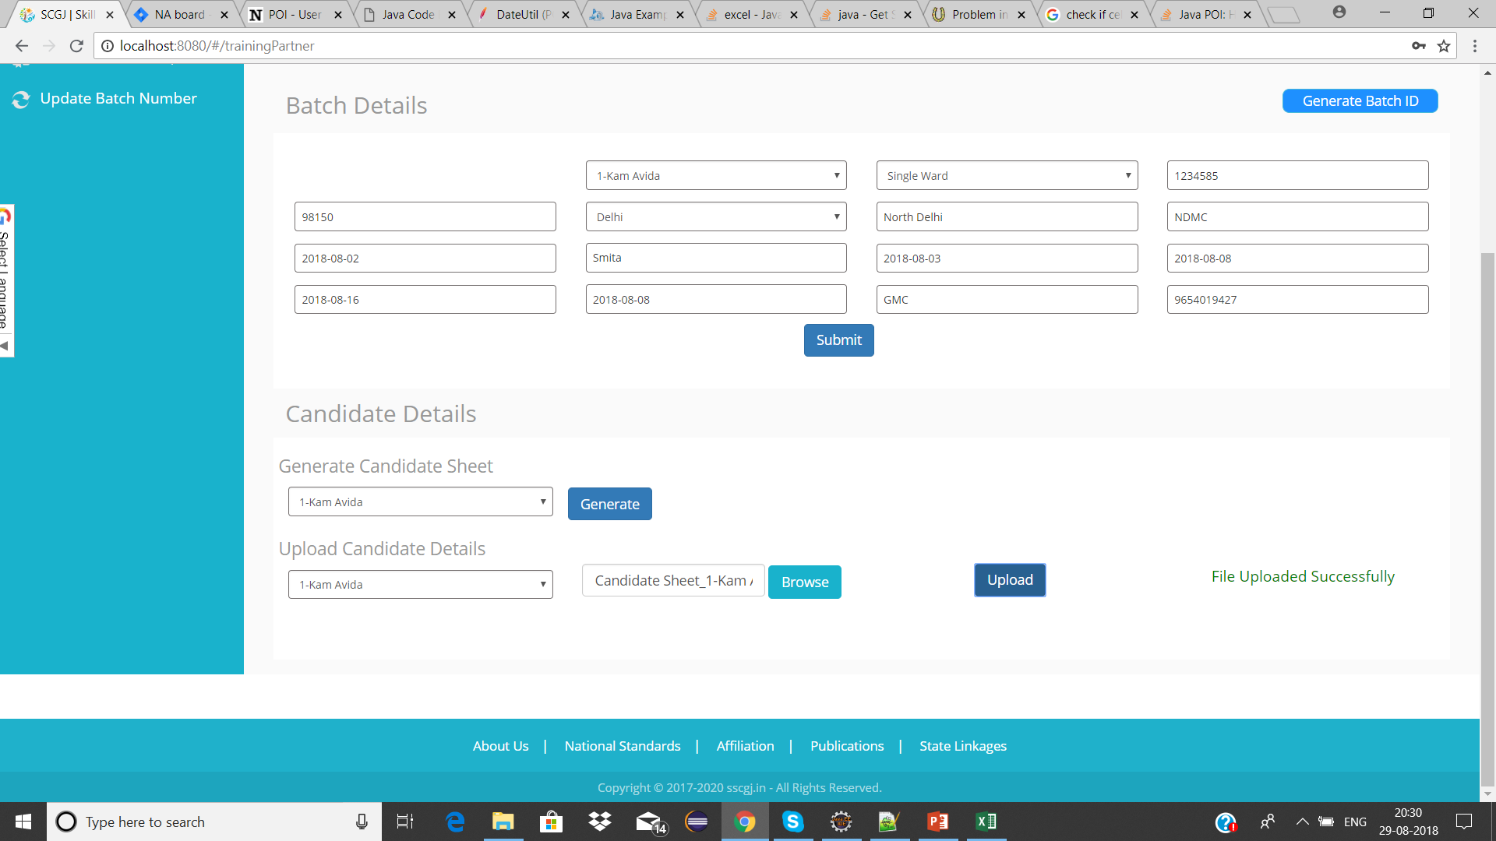

Note: *if the sheet is successfully generated then a success message saying “File Uploaded Successfully” will be generated.*

# Common Errors – Possible Solutions

Below are some common errors that a training partner might face while uploading the candidate sheet with some possible solutions to those problems.

|  |  |
| --- | --- |
| Common Errors | Possible Solution |
| Batch Id in sheet does not match the Batch Id selected. | Check the Batch Id in sheet and the Batch – Id selected from the drop down |
| Enrolment Number cannot be empty | Check if the enrolment number of all the candidates are entered |
| First Name of candidate cannot be empty | Check if the first name of the candidate is empty |
| Gender cannot be empty | Check if gender of any candidate is empty |
| Date of Birth cannot be empty | Check if date of birth of any candidate is empty |
| Change the format of date of birth to (dd-mm-yyyy) | Select the DOB column and change its format to (dd-mm-yyyy) |
| Age cannot be less than 18 years | Check if any candidate’s age is less than 18 as per the DOB |
| Aadhaar Number cannot be less than 12 digits | The length of aadhaar number cannot be less than 12 digits |
| Aadhaar Number cannot be more than 12 digits | Aadhar number must not have more than 12 digits |
| Duplicate Entry found for Aadhaar Number/Mobile Number | Check if there are any candidates whose mobile/Aadhaar number are the same |
| Residential Address cannot be empty | Check if the residential address the candidate is empty |
| Workplace address cannot be empty | Check if the workplace address is filled for every candidate |
| Invalid value for column | The column should only have a specific type of value (ex: numeric, text) |